Chapter 21. Workflow—Kanban and Kamishibai: Just-in-Time Rationalization
A Kaizen [continuous improvement] culture is one in which individuals feel empowered, act without fear, affiliate spontaneously, collaborate, and innovate.

Introduction
This chapter will address the challenges of managing many smaller tasks. This view divides knowledge work into two categories: the large and medium projects and initiatives that were the subject of the previous two chapters and the smaller tasks that are too numerous to be managed with a full project canvas or its equivalent. It’s common for people in knowledge work to have one or two main projects or initiatives that occupy a large portion of their time: a Salesperson with a key account to win over, a scientist with an invention to validate, or a CFO leading a merger. But for most of us there are also tens of smaller tasks that must be done: three patents to evaluate for the attorney, reviewing accounts payable for the quarter, making this month’s sales quotas. While any one of these smaller tasks may not be that complicated itself, the large number of them active at any one time can be overwhelming. These types of workflows vary so much that they require different techniques.
Smaller tasks create complexity in numerous ways beyond just their large number. For one thing, the number of people who can place demands for smaller tasks is often large: HR asking for an evaluation of a new candidate, the boss asking for support for a presentation, Purchasing asking for help with a part that’s difficult to procure, Sales asking for a small modification to billing software, Applications needing help with a customer complaint. Another point of complexity is the way scope can change. Operations needs a “small” change in a drawing but, after the drawing is changed, it turns out a certification has to be revalidated and that will take two months. You are asked to scan the competitive landscape and something unexpected turns up; now a product strategy has to be updated.
In many organizations, these smaller tasks are essentially unmanaged: given to knowledge staff to get done somehow. When there’s more to be done than there’s time for and there’s no easy way for staff to know which has priority. Shingo said “Immature plans and vague instructions are given out and the rest is left to hose who implement them. Whenever some blunder or confusion occurs…managers ignore their own shortcomings and bawl out subordinates.” In this case, it’s worse because the vague instructions results in the team being assigned tasks that exceed their capacity, what we will call an unrationalized workload; there is no way to meet expectations. This is the root of the waste of No-Win Contests.
The techniques of this chapter maintain a rationalized workload for a multitude of small tasks. We will discuss the mindset of “Ruthless Rationalization”: never accept work that when properly done, exceeds the team’s capacity. Ruthless Rationalization guides leaders to agree on goals, make plans to meet them and, when the workload is beyond the capacity of the team, renegotiate either the goals or the resources, or both. Then we will take up two well-known visual techniques for rationalizing smaller tasks: 1) a Kanban board for irregular tasks (that is, tasks that are highly varying in size and timing) and 2) a Kamishibai board for many tasks that repeat at a set cadence like monthly project reviews or quarterly performance reviews; in this chapter, these will be referred to as regular tasks.
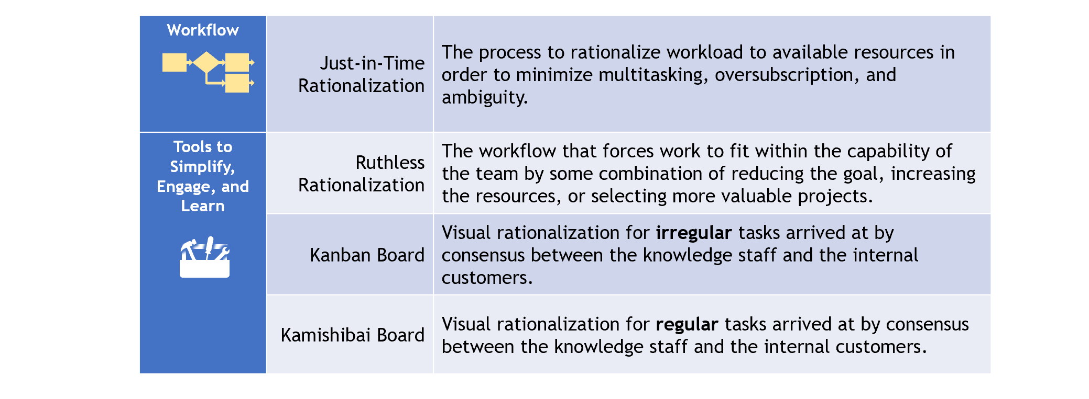
Figure 21-1. The workflow and tools of Just-in-Time Rationalization

The Eight Wastes
The Wastes from working on an unrationalized workload are common in knowledge work. Work gets behind and more work gets added. The people doing the work feel constantly overloaded and the people who need the work done feel almost nothing happens unless they “push” with frequent reminders and complaints. Everyone in the organization is losing in a giant traffic jam where tasks on the “highway” are backed up miles and yet new tasks keep being added.
Alexia is a web developer who is enduring a stressful morning because of her unrationalized workload (Figure 21-2). She comes in focused on Kim’s request for website screen updates needed to finalize a print ad that must be placed today. She’s not sure how she let it go so long, but she’s confident she’ll get it done on time—it’s only two hours of work and she has the whole morning. She sits down at 8:00 ready to get to work. Unfortunately, about 20 minutes later, she gets a call from John, who’s upset about a “critical” bug he just found in the website. He says this is top priority. He’s convincing and she thinks she can knock that out in an hour so she puts down Kim’s project and works on the bug. Around 90 minutes Rich stops by for an update on the China website. She hasn’t started that yet; he’s unhappy and talks to her for almost 30 minutes, going over all the times he’s asked for it and why she should have started a month ago. Finally, he leaves and by 10:00 she puts out a quick fix to John’s critical bug. Doing a last-minute check, she discovers her fix won’t work on the EU eComm site. Now she has to start over on John’s bug. Right about then, she gets a call that Merix Inc. says the website failed a security compliance check and she needs to go over the details right now, which takes another 30 minutes. At 12:30 Kim calls for the webpage update, which Alexia completely forgot about. Kim is livid because now the submission deadline has passed; there wont’ be another chance for at least a month. They spend 10 minutes arguing. When she hangs up, she’s so angry she can hardly think about work.
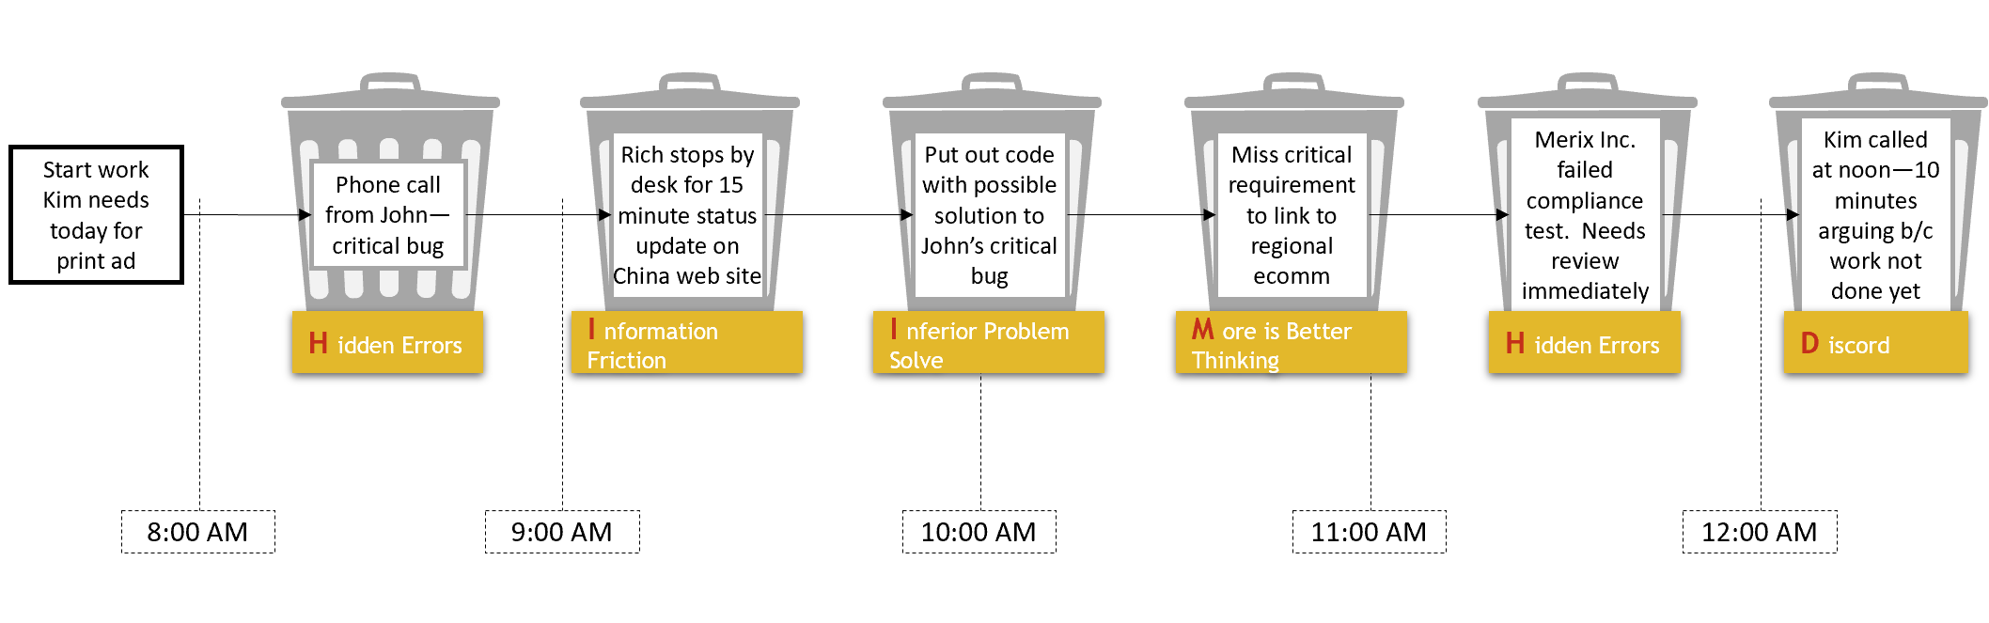
Figure 21-2 Alexia’s morning has plenty of waste from small tasks
Alexia is a victim of waste from an unrationalized workload. People call and stop by, each jockeying to get their project the highest priority. They push their projects, even when they aren’t the most important thing. She’ll later learn the bug John found could have waited a few days—it was in the website for months without being noticed. John’s forceful request won over Kim’s calm nature, but Kim’s job was much more urgent. But how could Alexia have known that when she decided to drop Kim’s job?
Figure 21-3 shows examples in each of the 8 Wastes. Discord in the organization is common because there’s not a reliable way to agree on priority of work. Instead, work is doled out faster than the organization can process it, and everyone has to elbow in to get their work done. Tempers can flare when people learn that their work has been sitting idle. Information Friction is rampant when the only way to know if the task you need is being worked on is to ask and you better be asking every day to be sure your task didn’t get elbowed out yesterday. More-is-Better Thinking takes over because there’s no way to meet demand so let’s do “as much as we can” and get work done “as soon as possible.” Prioritization often demonstrates Inertia to Change because people have learned the only way to get work done is to push hard; they’re likely to be unwilling to take any solution that limits how much they can push. But the pushing is a large part of the waste: the reminder phone calls, the emails, and the explaining, none of which do anything to move work forward. By definition, overloading teams creates No-Win Contests. Inferior Problem Solving is common in overloaded teams because there isn’t enough time to look at issues diligently. An example of Solution Blindness is that once work weaves its way into the prioritized heap of work, there’s no easy way to take it out, even if new facts have come to light since the work was accepted. And one of the most damaging Hidden Errors is the critical task that gots lost in the confusion: the initiative that got dropped that lost us a customer, cost us a compliance fine, or shut down a manufacturing line due to obsolescence. And when there are 20 or 30 tasks stuck in a traffic jam, it’s easier to lose track of the critical 1.
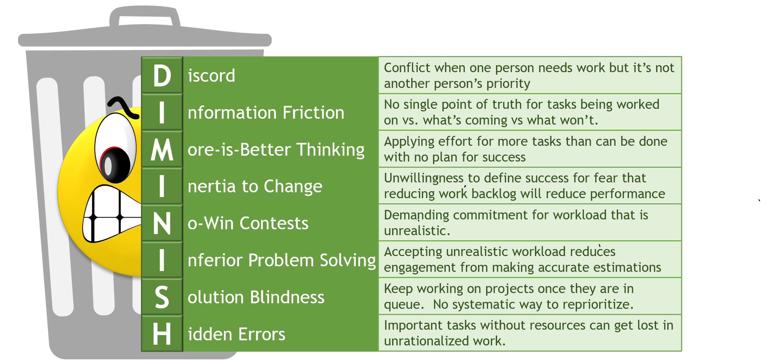
Figure 21-3. Examples of the 8 Waste from an unrationalized workload

Ruthless Rationalization
It is this moment of courage that begins the battle against the waste of oversubscription:
we will commit to no more than we believe we can do.”
Ruthless Rationalization is just common sense: never agree to do something you know you cannot do. In fact, it’s even an outcome of ethics: agreeing to something you know won’t happen is a kind of misrepresentation. If it’s common sense and it’s ethical to avoid, you would think it’s rare for people to take on work beyond their capacity. Unfortunately, that’s not the case. When the boss or the customer or an always-angry salesperson relentlessly pressure for a date that cannot be met, they will probably exit the conversation satisfied that their project is on top. In reality, they are stuck in systemic waste where people are exerting large effort for a momentary win. The organization needs a confident and capable expert who diligently estimates effort and then ruthlessly rationalizes the workload. It is this moment of courage that begins the battle against the waste of oversubscription: “we will commit to no more than we believe we can do.”
Ruthless Rationalization is shown in three-steps in Figure 21-4. It begins by defining a goal: the number of a certain type of task or initiative per week, an amount of revenue secured, or a date by when a service or product will comply with a regulation. Goals are determined in units of value such as those in the value gem of Figure 3-1; goals are usually created from leadership and negotiated with staff. Quantify to communicate (Section 6.4.1), understanding the goal will change over time because of the uncertainty in the first iteration. The third step is to identify the set of work the team will take on. The final check is to ensure the resources are rationalized to the work. If not, we must be “ruthless”: either 1) renegotiate the goal, 2) increase the resources, or 3) increase the total value of the workload; the value of the work set is increased by modifying existing tasks and initiatives or finding more valuable alternatives to those we have. Ruthless rationalization treats an unrationalized workload as a “Stop-Fix” alarm.
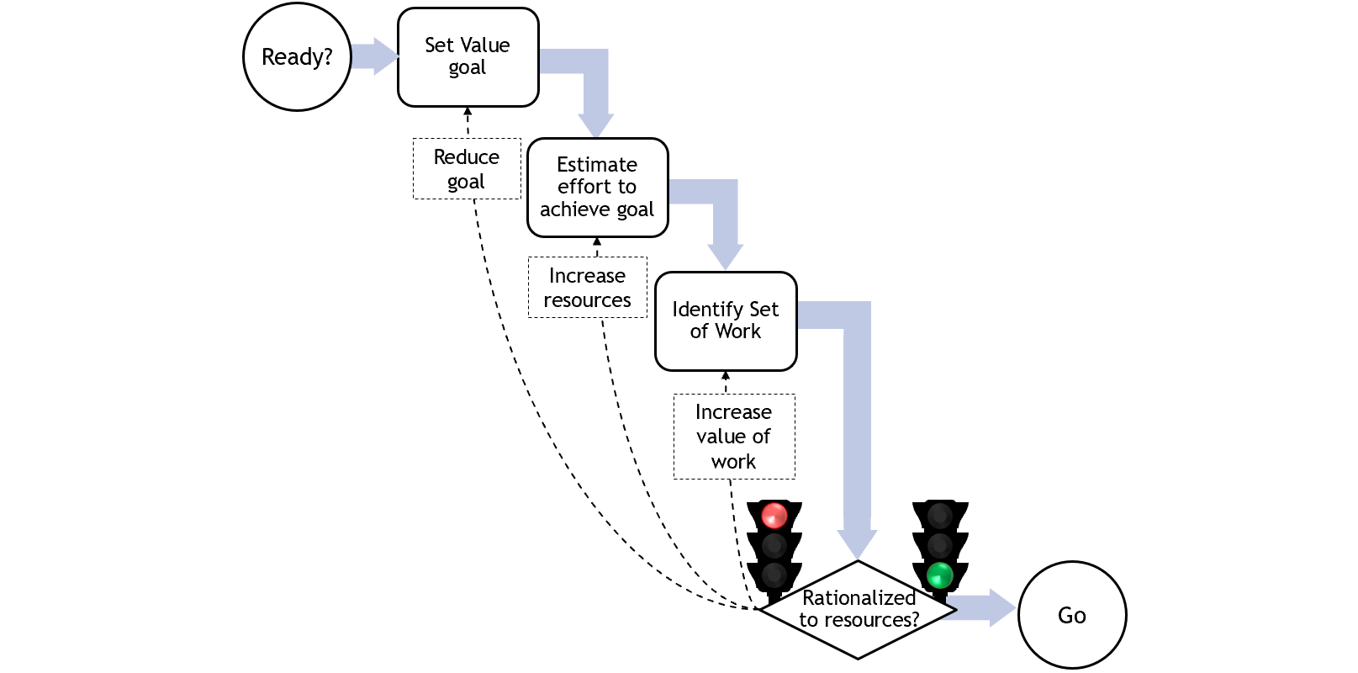
Figure 21-4. Ruthless Rationalization treats an unrationalized workload as a Stop-Fix alarm

Just-in-Time Rationalization
The remainder of this chapter will apply “Ruthless Rationalization” to tasks and small projects. For many teams, everyday work can come from competing customers, both internal and external. This can be harder to rationalize than a large project, which could have a dedicated team. Dedicated teams simplify the job of rationalization because there are a smaller number of competing interests, all of which want to see the project successful. In everyday work, we might take requests from many functions—Product Marketing, Operations, Finance, HR, and General Management—none of which may help weigh their priorities against the others.

Prioritize
The first step in rationalizing is prioritizing, as shown in Figure 21-5. We start with many tasks and let’s assume it’s not possible to do them all (a safe assumption in most knowledge work!). After that we can prioritize, which begins by filling up the workload with the highest value projects possible. After getting an initial set of tasks, check that set against the team’s goals. For example, if the primary task of a sales team is to generate in-year revenue, prioritize the tasks by revenue, pick as many as the team can support, and sum the revenue. If it’s enough to meet the goals and to satisfy the other requirements of the organization, rationalization is complete. Normally, it’s not that simple. Most knowledge-work teams support varying needs: taking care of key customers, add new customers, and meet regulatory needs are a few examples. So the rationalized set must meet multiple goals.

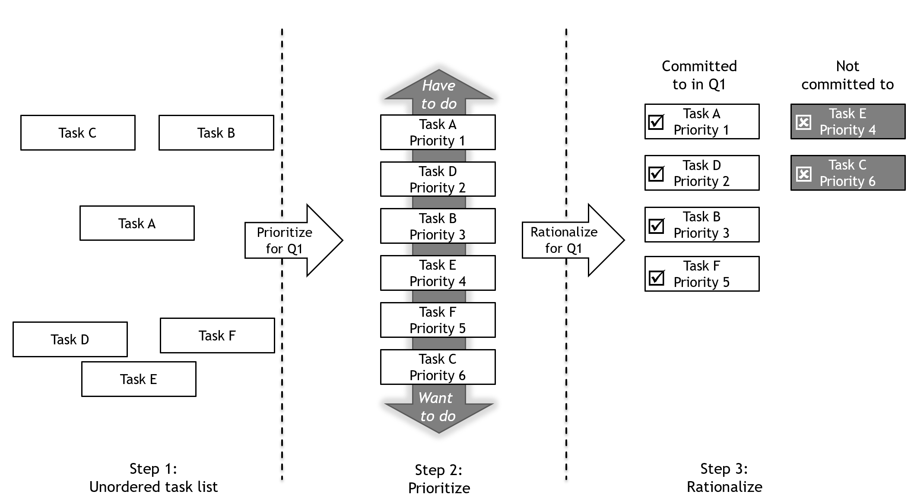
Figure 21-5. Rationalization is a process that depends on prioritization
You might have noticed in Figure 21-5 that Task F (Priority 5) was selected in front of Task E (Priority 4). This is normal—force ranking priority must be done over a narrow set of measures, so it almost never tells the full story. Instead, business acumen and technical knowledge must be applied to identify a full work set; don’t expect to fill in a spreadsheet and get the answer.
People struggle with this approach at work, thinking it’s not possible to rationalize because there are so many differing needs. But we do it every day with our budget at home. Our money satisfies many competing needs, some urgent, some important, some both and some neither. We all have bills that must be paid (taxes and electricity), but there are many complex tradeoffs: do I save for the college fund or go out to eat? Do I take a vacation or add a bedroom to the house? There is no simple rule, but budget discipline begins by deciding that you will live within a budget, which is an expression of ruthless rationalization.
Forecasting workload is complex. There are always unknowns—work sometimes comes in bunches, something we can call “uneven flow”, and domain issues can be unpredictable. In these cases, experts must willingly shoulder the load to estimate as well as possible, track actual against commitments, and learn to be better the next time. Over months and years, expertise will grow and estimates will steadily improve. Don’t be satisfied with “it depends” or “we don’t know”. Of course, it depends. Of course, we don’t know with certainty. That’s why knowledge work relies so heavily on experts.

Kanban Task Management
Kanban is a bit like the Chinese board game Go—a few moments to learn, a lifetime to master.
A Kanban board is a visual way to perform Just-in-Time Rationalization with work that varies. It helps teams deal with uneven flow of tasks and it helps internal customers see what the team is working on. The Kanban board is based on Kanban Inventory Management, which was derived by Taiichi Ohno and others in Toyota from American supermarkets in the 1950s. Kanban Task Management was applied to knowledge work on a large scale by David Anderson who helped develop Agile Software Management. The concept can be demonstrated with an ordinary lunch buffet at a pizza restaurant as shown in Figure 21-6. When a server 1) sees a type of pizza is running low, she 2) signals a request to the kitchen for more pepperoni pizzas. The kitchen 3) starts a new pizza and a few minutes later 4) delivers it to the buffet table.
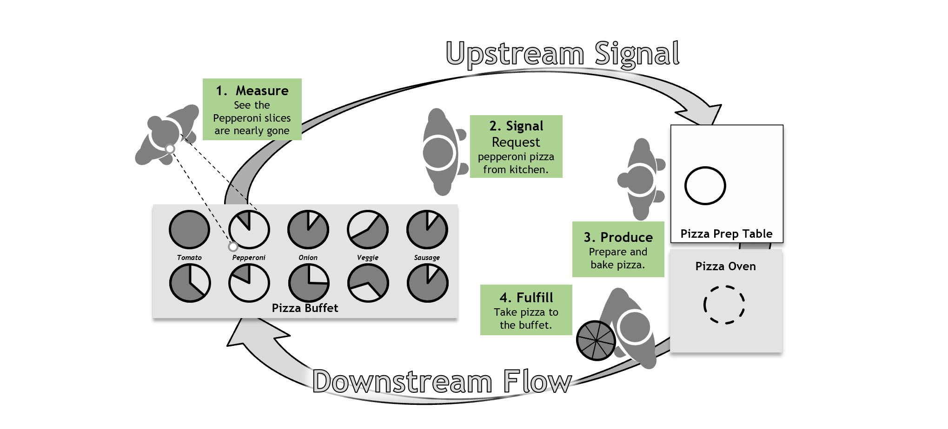
Figure 21-6. A pizza buffet is a pull system with downstream flow driven by upstream signals
The key lean principle in Figure 21-6 is to see how the “upstream signals” trigger the “downstream” flow. These signals help the restaurant respond when, for whatever reason, pepperoni slices are taken half the rate one day compared to the next. They are the key to the Kanban board of Figure 21-7. This is a physical board with sticky notes that flow from left to right. Each note represents one task. The backlog of tasks that is unlimited; any customer to the process can add work to the backlog, but there’s no commitment on when the backlogged work will start implying, of course, that entering a task in the backlog gives no indication of when the task will be done.
The unapologetic lack of commitment to tasks in backlog is probably the most counterintuitive part of Kanban. People seem to expect that how much effort they expend to get the project prioritized should be a primary factor in that project’s level of priority. In fact, projects ought to be selected by one measure: how much value do we add. If it’s low, it does not matter how long ago it was requested. Contrast this with the common complaint: “I’ve been asking for this for months!” I’m not sure why someone would think a low-value task asked for six months ago should be selected over a high-value task requested yesterday. The Kanban board is a simple expression of this logic.

How Kanban Works
To understand how work flows in Kanban boards, we must start on the right side of the board. The “Done” column is intuitive; when a task is “Confirmed” complete (that is, accepted by the customer), it makes its final move to the right. Perhaps we leave it there a week or two, and then remove it from the board and story it for future reference.
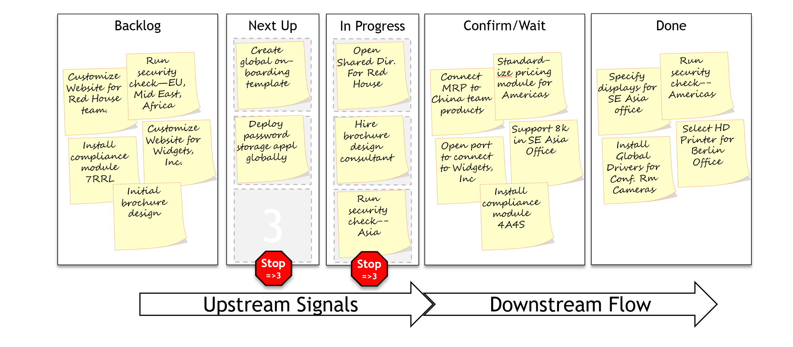
Figure 21-7. A Kanban board creates a pull-system for task management
When a task in the “In Progress” column gets finished, it can go to the right to await confirmation. And here is the first signal: the Kanban board ruthlessly rationalizes by limiting the maximum number of tasks in progress, here to three. There are multiple techniques to set the queue and the total number is probably the simplest.
David Anderson points out that there are many ways to visualize tasks that look like Kanban boards. But the test of true Kanban is it must limit “work in progress”, shown here as stop signs in “Next up” and “In Progress,” and the pull signals that fill the work to those limits. Anderson says, “…if there is no explicit limit to work-in-progress and no signaling to pull new work through the system, it is not a Kanban system.”
The next column to the left is “Next Up,” which is the next set of tasks that have been prioritized. When a slot opens in “In Progress” the team can, at any time, pull from “Next Up.” “Next Up” is filled by customers. A common approach is for the full team including internal customers to meet 15 or 20 minutes once every week or two to fill Next Up enough to occupy the team until the next meeting.
Prioritization: So, “Next Up” ensures customers (usually internal customers) are prioritizing the work just as the decisions are needed. Made too soon, decisions are deprived of the maximum amount of information; made too late, the indecision can delay and discourages the team. The work is always rationalized by the limits on “In Progress.”
Rationalization: Limits on “In Progress” ensure the team is constantly rationalized to the workload. Commitments are made on tasks that are at “Next Up” or perhaps when they enter “In Progress”; no commitments are ever made for backlog tasks.
The Kanban board is the single point of truth for what is being worked on. There is no need to place phone calls or spew out emails for status; the Kanban board has the status. And, there is no reason to use personal networks or force of personality to rachet up priority on your favorite project. Come to the weekly prioritization meeting and make your case with the other internal customers.

Eliminate the Waste of Estimation
You probably noticed that all tasks are treated the same: one sticky note for large and small alike. In Kanban, we are not juggling multiple tasks trying to fit a schedule that brings in the many tasks to target dates. Kanban, “lets the flow manage the process” as Taiichi Ohno is often quoted; when one task finishes, the next can start. This cuts the waste of estimation, which can be very large indeed. Suppose a task comes into a traditional system—the task customer negotiates a schedule for the task, which if missed must be renegotiated, and if that if missed, renegotiated again. The effort for all estimations but the final is pure waste.
One practice I’ve seen work was to do the rough estimates, spending a few minutes so something like T-shirt sizing (small, medium, large) of effort and value. Internal customers decided what moved forward; the people doing the work provided absolutely no commitment to a delivery date before the task was pulled into Next up. This sometimes led to hard feelings when someone had a task in backlog six months. Our answer was this task was of such low value, the internal customers didn’t select it—either you need to make your case better or you need a task with a better return.
The Kanban board works well for independent tasks such as are common in IT—those lasting a few weeks and coordinating the activities of a few people. It immediately eliminates waste from No-Win Contests because “A pull system cannot be overload if the capacity…has been set appropriately.” Larger projects need the sort of planning discussed in Chapters 19 and 20. But even for groups that spend most of their time in large projects like R&D, business development, or legal cases, the Kanban board can be used on the slice of resources that goes to small projects and so bring order to that part of the group’s responsibilities. For those teams that are almost entirely committed to smaller projects (e.g., many IT groups and customization development teams), the whole department may be managed with a Kanban board.

Kanban Dashboard
The Kanban board shows flow of tasks but does not visualize performance. For example, measures of value like total revenue generated or %-on-time (e.g., compared to commitment at Next Up) are not displayed. For that, a complementary visualization is needed such as the dashboard of Figure 21-8. (Section 8.5.1 details dashboards.) Anderson suggests a dozen or so metrics that can be used to create continuous improvement , .
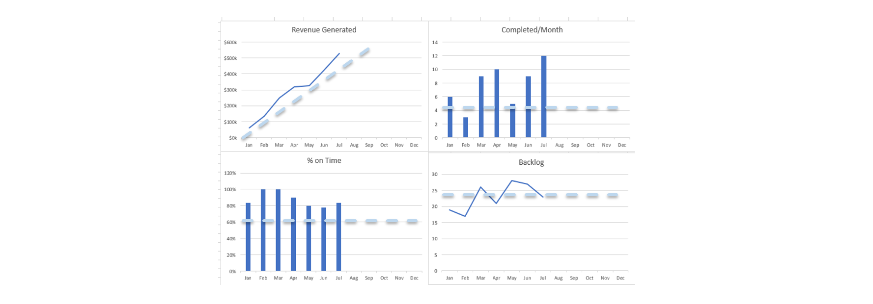
Figure 21-8. A typical dashboard for a Kanban measures performance from four perspectives: created value (revenue), task completion rate, on-time delivery, and backlog size.
It’s important to provide performance measures along with the Kanban board; otherwise internal stakeholders are likely to have poor understanding of the Kanban’s contribution to the organization over time. As shown in Figure 21-9, the Kanban board provides constant rationalization to transact the generation of value. But measuring value over time provides a larger view, always asking if we are doing what the organization most needs, guiding us to transform the Kanban board by fitting and refitting it to current needs.
My experience is the dashboard or other performance measures may not be needed initially, because the Kanban board brings quick, obvious improvement; a lot more gets done and people are happier doing it. But over time, memories fade; the organization habituates to the improvement that a year ago was obvious. To sustain the Kanban over years, you’ll want a complementary display for value generation. The Kanban transacts work to maximize defined value; the dashboard transforms the way we define what’s most value.
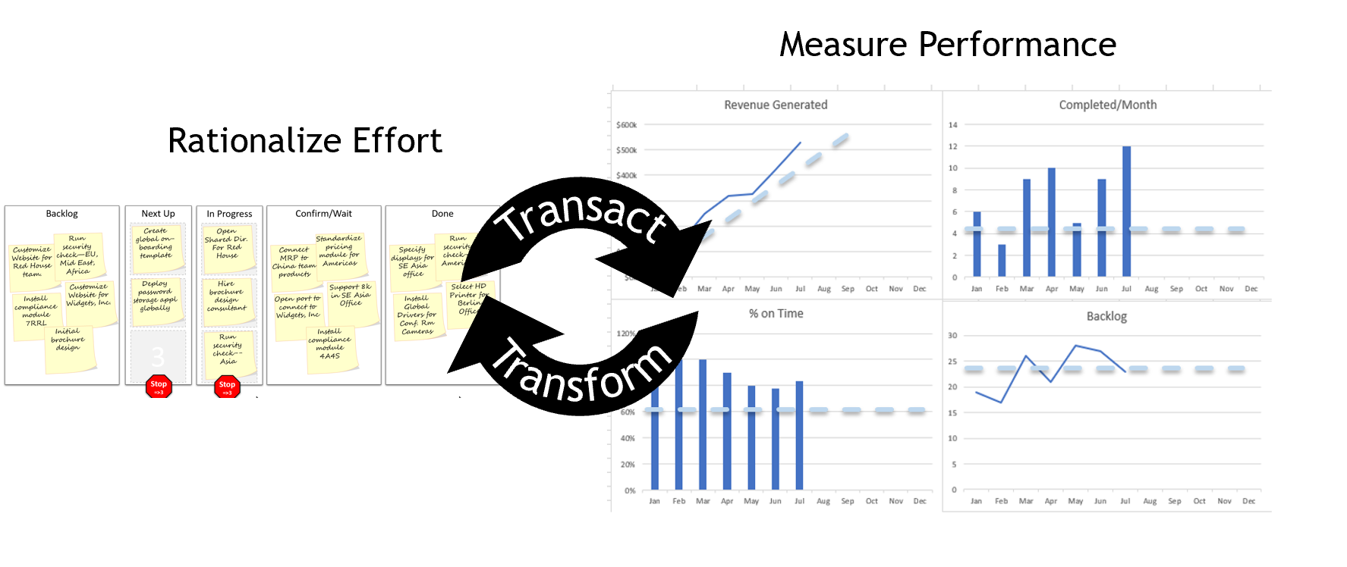
Figure 21-9. The Kanban board prioritizes tasks to transact our work.
The dashboard measures performance to transform how we prioritize.

How to Start with Kanban Project Management (KPM)
Perhaps the best advice for those who want to try KPM is to try it first as a board for managing personal daily work. I took that advice and never looked back. I created the Kanban board shown in Figure 21-10 with four sheets of printer paper and a stack of sticky notes; it was taped up beside my desk so I could never go more than a few minutes without seeing it. I tried it on a web-based Kanban application, but prefer the accessibility paper provides. It immediately brought order to my workday. It also helped me cut down on multitasking. When On deck or Do are overloaded, I return a sticky to Backlog. One personal improvement came when I recognized I was much more efficient at email when I attack it in uninterrupted blocks of time. So now I’m more likely to process 20 or 30 emails in 30 min rather than trying to do a few here and there. Also, I added a Kanban category “Wait for Response” that I needed it since my Kanban typically flows in a matter of days, but people often take a week or two to respond. Years later, my Kanban board is constantly changing.
Today I travel more; I prefer the Kanban board in physical format when I’m home and convert to digital when I’m traveling—often by photographing the cards on my physical board and pasting them into my traveling PowerPoint® Kanban. Over the last 10 years, I’ve had many Kanban boards, but I’ve never gone long without one.

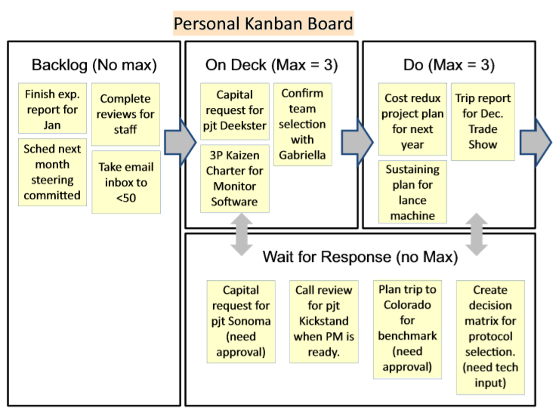
Figure 21-10. Author's personal Kanban board for daily management
[Ed: Fig 7-19 in Project Management for Product Development]

Virtual or Physical?
One of the first decisions to make is whether the board will be paper or virtual: stored electronically and viewed on a screen. Don’t be drawn to the sparkle of a full-feature Kanban software system. Compared to sticky notes and felt markers, they are so polished as to make a physical board seem tired. But the physical board has something almost impossible to replicate with a virtual system: presence. It’s always there. Anyone can walk up and touch it. During the week, people start conversations and naturally wander to the physical wall, and point at a card…“I think I might know a better way…”. Walking in and out of an office area, it’s a natural place to stand and contemplate a knotted-up problem. Anderson recounts his early experience: “The physical board had a huge psychological effect compared to anything we got from the electronic tracking tool we used at Microsoft®.” He points out how having people standing at the board a few minutes each day created a dramatic increase in creativity and a high focus on resolving issues.
On the other hand, if your team is highly distributed, you’re likely to benefit from a software Kanban board. I’ve yet to see a video conferencing system that can convey a physical board to remote team members; as a result, those outside the room are always at a disadvantage. Over time, their voices will not be heard as well. I’ve installed numerous virtual and physical boards, and they’ve both worked. But the difference between data-base optimized, cloud-connected systems and the remarkably low-tech handwritten sticky notes has nothing to do with it. The board should reflect the team: if they are collocated, hang the board near them. If they are distributed, a virtual system will create a flatter playing field.

Kanban: a Lean Thinking Laboratory
The Kanban board provides perhaps the most unambiguous view of the Lean Equation (Chapter 4): over time, you will see the complex interplay of value, effort, and waste. It’s the ideal lab to learn lean thinking. Changes install quickly, and then produce results (or flop) in weeks. The team can improve as they see gaps. This creates what Anderson calls a “Kaizen culture” by empowering people. “Individuals feel free to take actions, free to the do the right thing. They spontaneously swarm on problems,…” I’ve watched this many times. First, an experienced facilitator leads the team to install Kanban. Then, that facilitator stays with the process for a month or two until the team enjoys a little success. Then the team starts changing their board. It never fails—come back a couple of months later and there will be so many changes such as modifying the content of the cards, changing the review team, adding metrics, and on and on. Unlike a heavy product development or business acquisition structure where the stakes for any one project are high, Kanban imparts a right and a duty to experiment in the relatively low risk workflow of small projects.
When implementing Kanban, make the fewest possible changes to your existing process. “You must resist the temptation to change workflow, job titles, roles and responsibilities, and specific working practices”. Changing nothing that effects people’s self-esteem or might injure egos. There’s no need. Simply make visible that which is hidden by waste: ambiguous priorities, wasteful multitasking, and persistent barriers.

The Kamishibai board: Smooth flow for periodic regular work
Where the Kanban board organizes irregular work—tasks and initiatives that vary in size and occur unpredictably—the Kamishibai board organizes regular work that occurs at regular intervals. For example, it can be used to ensure an even flow of project reviews. Let’s say we have 12 active projects that should have a 1-hour review at least every three months. The Kamishibai board provides visualization to encourage smooth flow of each task so the reviews are spread out at roughly one per week.
We set up a Kamishibai board for just this purpose and it was invaluable for creating a smooth flow. Before the Kamishibai board every couple of months we’d realized we had not reviewed any projects and then we had a raft of reviews to do in a week or so. This created frustration from the stress of having to schedule many reviews quickly; I also convinced the quality of the reviews during those rushed times failed to meet our standards. These are typical wastes of uneven workflow.
Giles Johnston gives a step-by-step guide to building a Kamishibai board, starting with “The first thing to do is to define the time period that you want to manage.” On the factory floor, the time period is often over a week or a month. In knowledge work, it may be months or even a year. The board will then show all tasks according to whether they are completed anyone can grasp the status in a glance.
A Kamishibai board shows a set of cards where each task is written on a two-sided card as shown in Figure 21-11, an example for project reviews. Note that the text on both sides of the card is identical. All cards are displayed on a single board, with those incomplete (here “unreviewed”) showing one side and those complete showing the other (see Figure 21-12). Normally, the cards are laminated; the card number is optional.
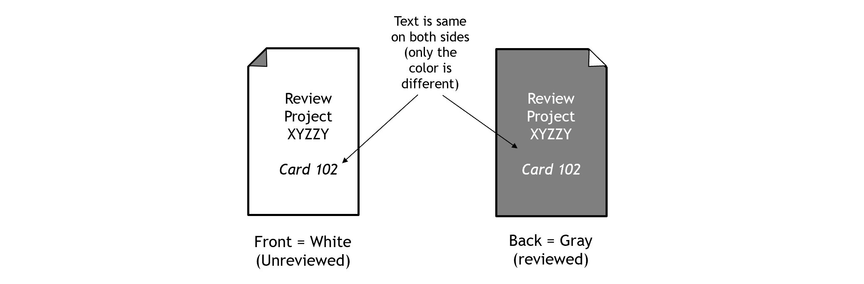
Figure 21-11. A Kamishibai card has identical text on both sides; one side shows the task open and the other shows it done.
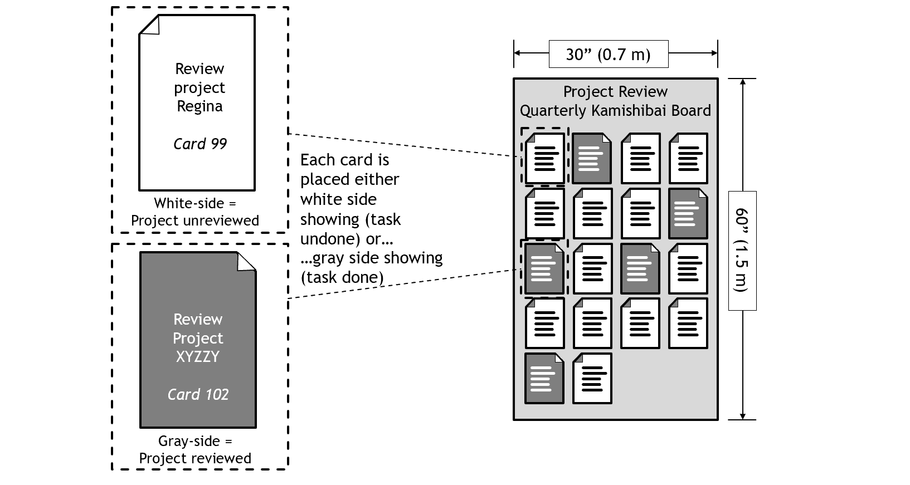
Figure 21-12. A Kamishibai board shows every project as either “reviewed” or “unreviewed”. Progress over the quarter is apparent in seconds.
Figure 21-13 shows the flow of the board over three months with the left frame showing the board at the start, the center frame showing the board about halfway through the quarter, and the right frame showing the board near the end of the quarter.
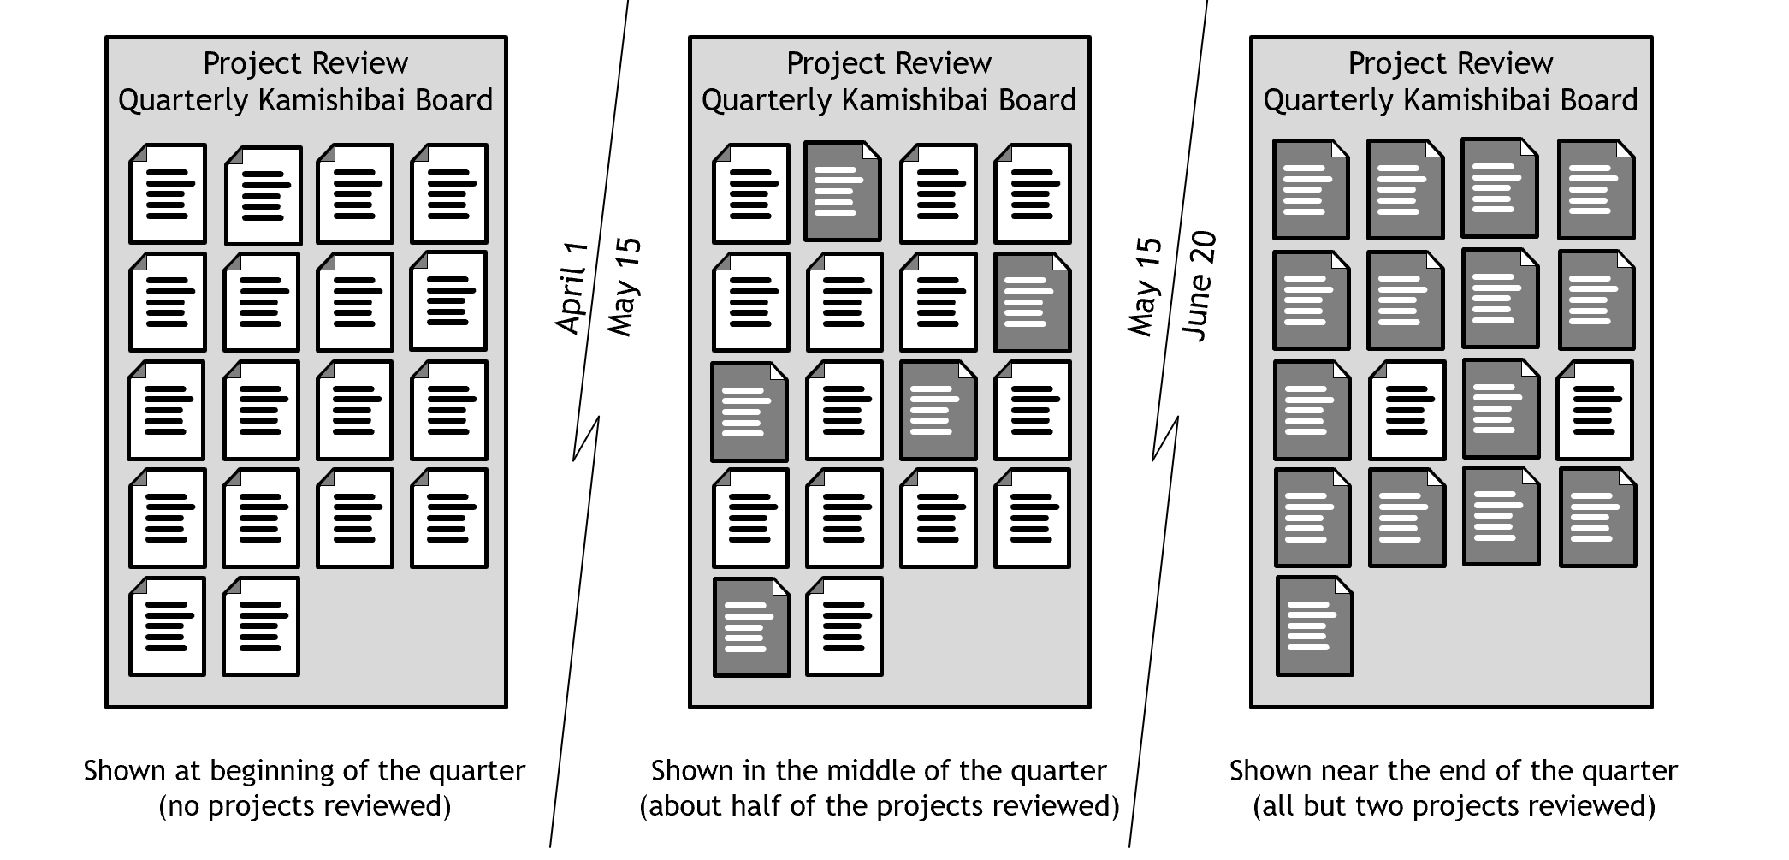
Figure 21-13. A Kamishibai board shows all cards visualizing progress over the quarter.
If you’d like to trystorm the Kamishibai board, consider using the sticky-note version shown in Figure 21-14. The function of the Kamishibai board can be put together in minutes with ordinary office supplies rather than spending weeks to purchase and hang permanent Kamishibai boards and make laminated cards just to try the idea.
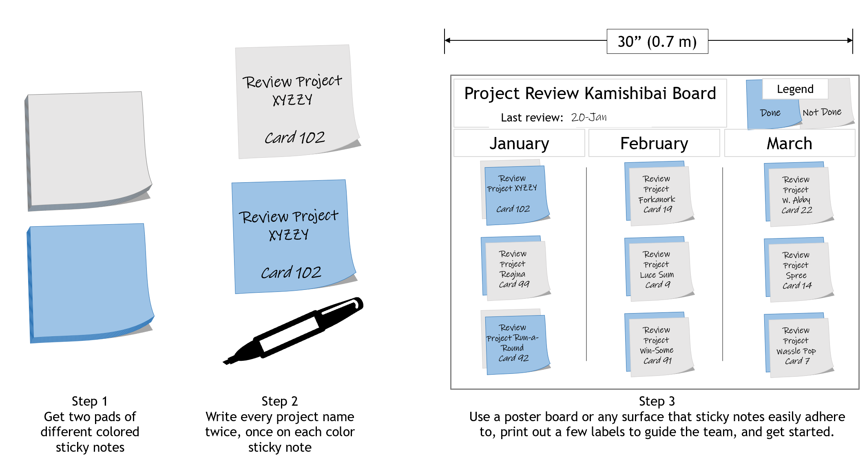
Figure 21-14. Trystorm a simple Kamishibai board with sticky notes and a white board

Knowledge Work Improvement Canvas (KWIC) to Adopt Just-in-Time Rationalization
Figure 18-8 shows a Knowledge Work Improvement Canvas (KWIC) to deploy a Kanban task management board.
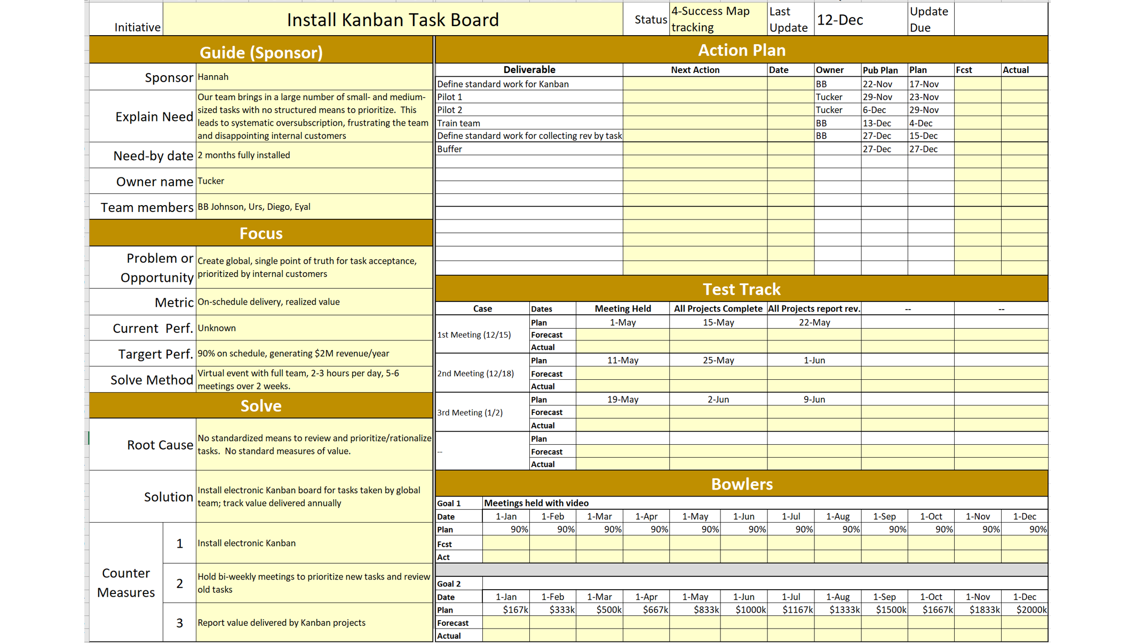
Figure 21-15. A Knowledge Work Improvement Canvas (KWIC) to Adopt the Solve-Select Workflow

Conclusion
The Just-in-Time Rationalization simplifies the way we prioritize work (see Figure 21-16). It also can increase engagement as shown by the Engagement Wheel. Knowing the team can and will delight their internal customers can be inspiring for those who today go home feeling that no matter how hard they work, they are not meeting the organization’s needs. It connects the internal customers and the staff who execute their tasks by working together to decide what’s most important. It gives a contest that can be won because work is optimally prioritized and constantly rationalized. And it protects the team by ensuring each task is done to completion before starting the next task. The dashboard creates an opportunity to experiment, measuring the value of work and thereby creating opportunities to gain insight on how to improve.
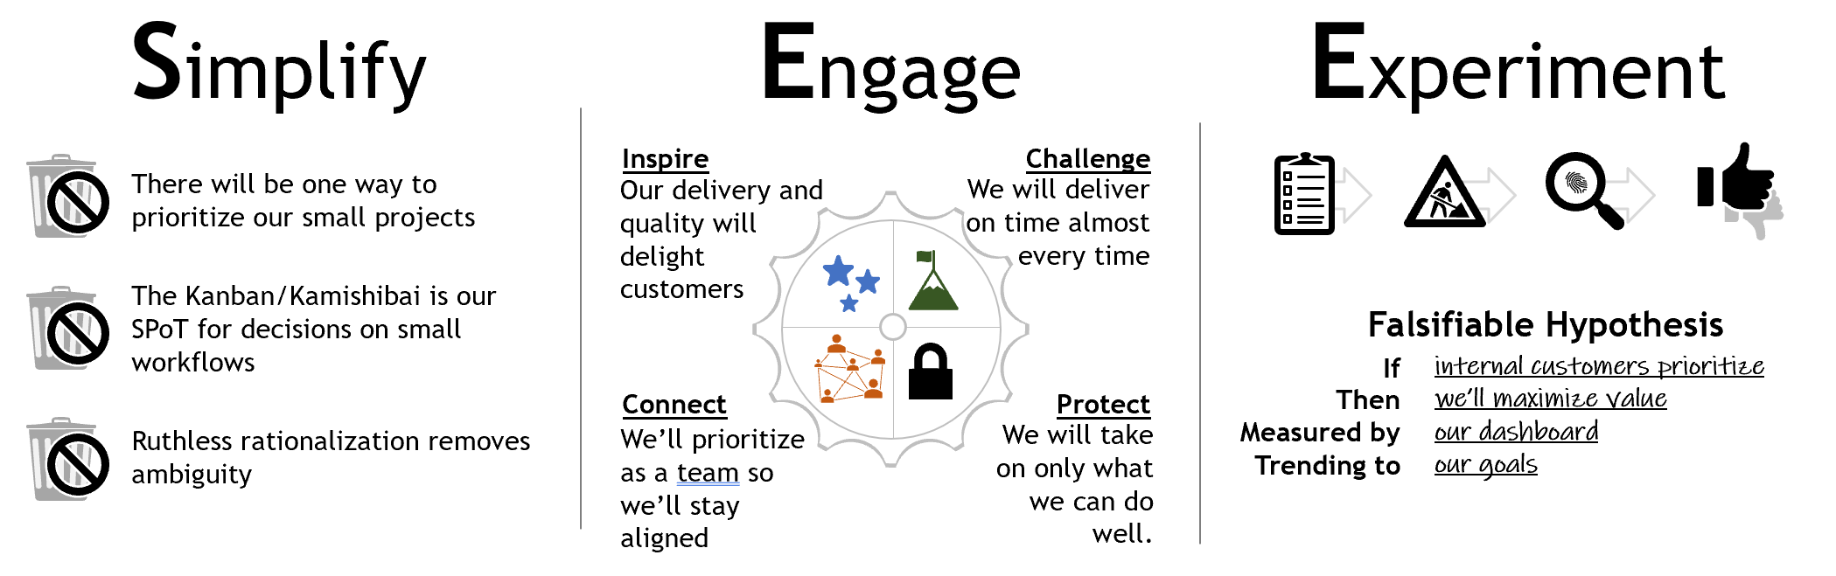
Figure 21-16. Just-in-Time Rationalization simplifies, engages and encourages experimentation

There is an unrelated use of the Kamishibai board for auditing, where a random card is picked daily. For example, going to a manufacturing cell each morning and randomly picking 1 card out of a stack of 100 potential topics to audit.
------------------------------------------------------CHAPTER 20----------------------------------------------------
David J. Anderson, Kanban: Successful Evolutionary Change for your Technology Business”, Blue Hole Press, 2010, p60
Sayings of Shigeo Shingo, p120
Mattias Skarin, Real-World Kanban: Do Less, Accomplish More, Pragmatic Bookshelf, 2015, Forward
Liker, Toyota Way, p106
David J. Anderson, Kanban, Forward
Visual Project Management, p87-93
Anderson, p114-116
David J. Anderson, Kanban p14
David J. Anderson, Kanban , p39
Anderson, p13
Anderson, p139-146
Anderson D. Deep Kanban, worth the investment? London Lean Kanban Day; 2013. https:// www.youtube.com/watch?v=JgMOhitbD7M.
Anderson D. Deep Kanban, worth the investment? London Lean Kanban Day; 2013. https:// www.youtube.com/watch?v=JgMOhitbD7M.
Anderson, Kanban book, p55.
Anderson, Kanban book, p50.
Anderson, Kanban book, p63
Johnston, Giles. Kamishibai Boards: A Visual Management Tool to Improve 5S and Create Effective Habits (The Business Productivity Series Book 9) . Unknown. Kindle Edition.

